Goal: This document serves as a reference for the use of the BBBSEM Salesforce sandbox for the Fall 2023 engagement. It will outline how to find the flows used in communications to bigs and littles in the network as well as the associated communications.

**Step 1:**

Using the **BBBSMB Program** homepage, navigate to the cog icon in the top right corner, and click on setup as seen below. This is where all the flows and communications are housed.

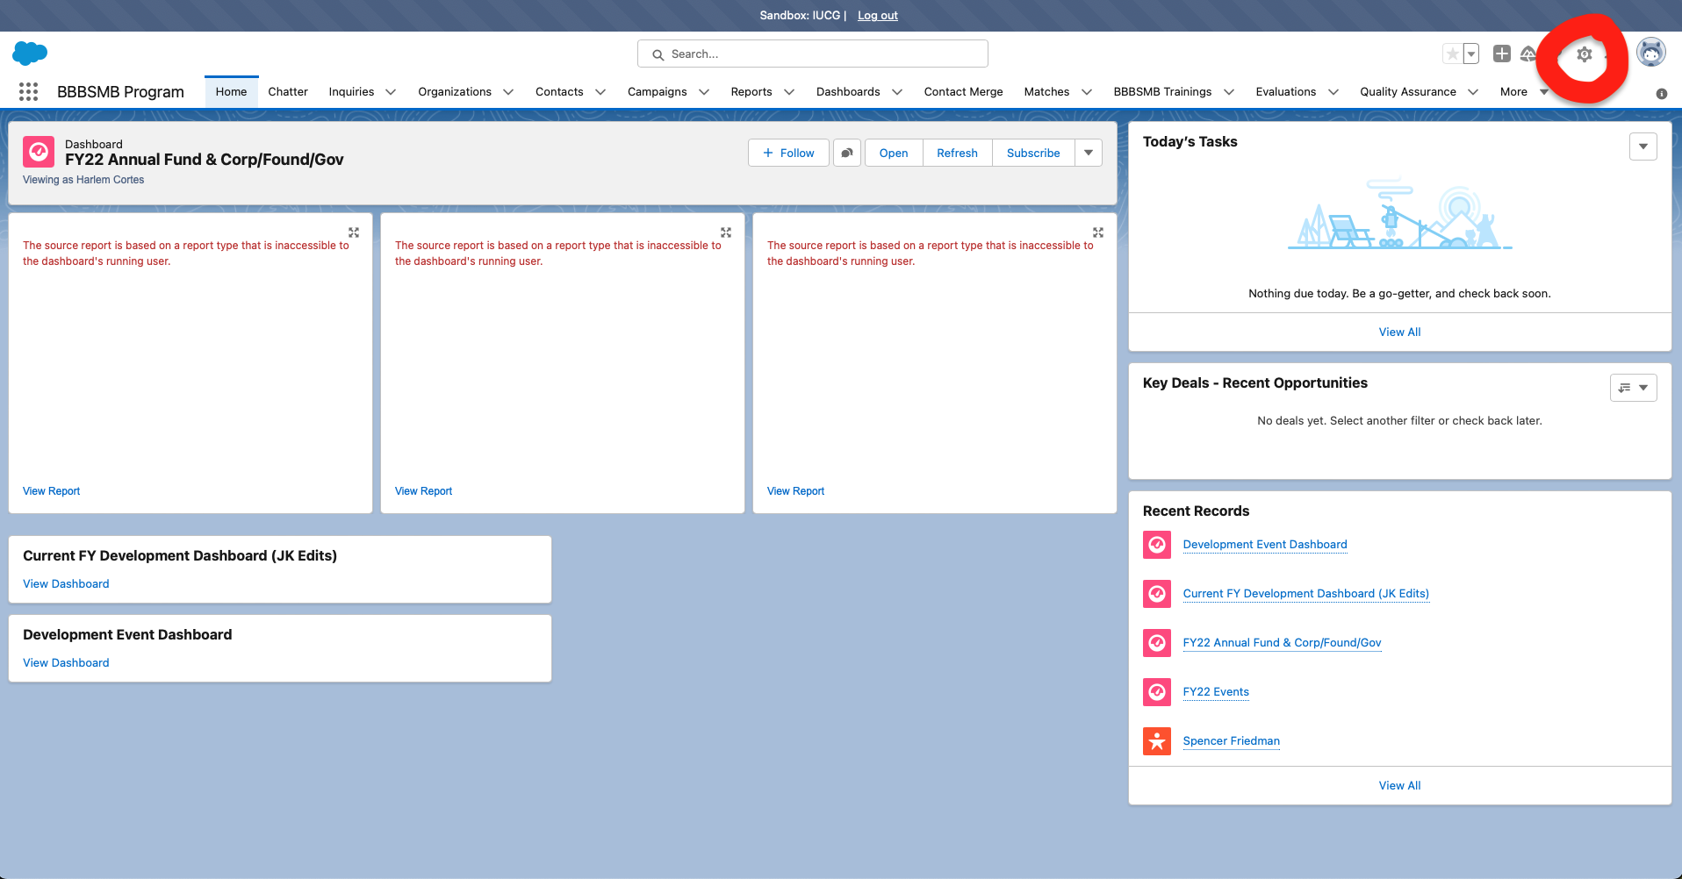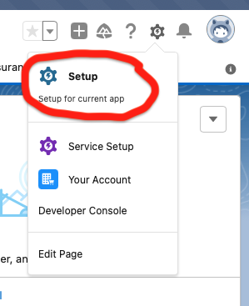

**Step 2:**

Once you have clicked on Setup, use the search bar on the left side to search for “Flows”, which are the automated processes that distribute communications to the volunteers and families.

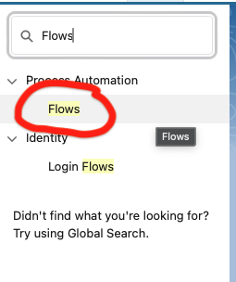

**Step 3:**

Once you have found the active flow that you want to investigate, select the icon of the communication you are interested in, click on edit, and take down the name of the communication file as seen below.

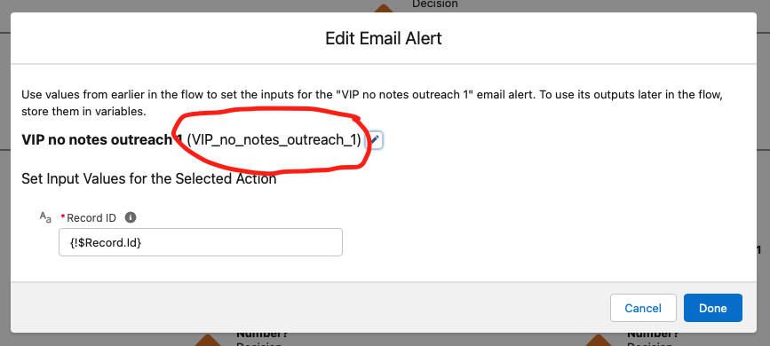

**Step 4:**

Navigate back to the Setup search bar and look up “Email Alerts” and find the matching name to find the template for the communication associated with that step in the process.

